H.T No
Regulations:
A22

Sreenidhi Institute of Science and Technology
(An Autonomous Institution)
Code No: 9AC42 Date: 30-Aug-2023 (FN)

B.Tech I-Year II- Semester External Examination, Aug/Sept-2023 (Regular)
ELECTRICAL CIRCUITS & NETWORK ANALYSIS (ECE and ECM)

Time: 3 Hours Max.Marks:60

Note: a) No additional answer sheets will be provided.
b) All sub-parts of a question must be answered at one place only, otherwise it will not be valued.
c) Missing data can be assumed suitably.
Bloom's Cognitive Levels of Learning (BCLL)

Remember | L1 | Apply | L3 | Evaluate | L5
Understand | L2 | Analyze | L4 | Create | L6

Part - A Max.Marks: 6x2=12

Answer all QUESTIONS, EACH QUESTION CARRIES 2 MARKS.

 |  | BCLL | CO(s) | Marks
1 | State and explain KCL and KVL. | L1 | CO1 | [2M]
2 | Define resonance, write its condition. | L2 | CO2 | [2M]
3 | Compare between electric and magnetic circuit. | L5 | CO3 | [2M]
4 | Explain the Millman’s theorems. | L6 | CO4 | [2M]
5 | Write the equation of ABCD and h- parameter. | L1 | CO5 | [2M]
6 | Calculate time constant of RL circuit with R=100 ohm and L=20mH. | L3 | CO6 | [2M]

Part – B Max.Marks: 6x8=48
ANSWER ALL QUESTIONS. EACH QUESTION CARRIES 8 MARKS.

 |  |  | BCLL | CO(s) | Marks
7. | a) | Determine all branch current and the voltage across the 6 resistor by mesh analysis for the network shown in figure.  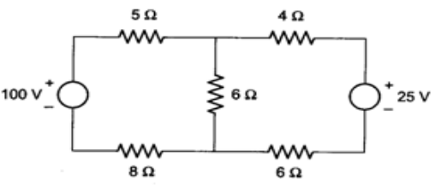 | L5 | CO1 | [8M]
 |  | OR
 | b) | Discuss Star-delta delta to Star transformation. | L2 | CO1 | [8M]
8. | a) | Develop the expression for resonant frequency, bandwidth and quality factor of RLC series circuit. | L4 | CO2 | [8M]
 |  | OR
 | b) | Determine RMS and average values shown for the following wave form.  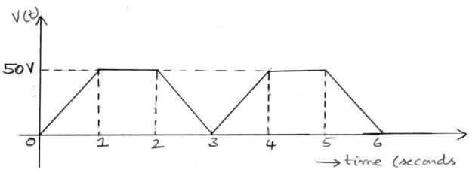 | L5 | CO2 | [8M]
9. | a) | Calculate the resonant frequency, quality factor and band width a series combination of resistance of 200Ω and a coil with inductance 1 H and winding resistance 10Ω and a capacitor of 0.5 μF is connected to an AC supply with internal resistance 5 Ω. | L3 | CO3 | [8M]
 |  | OR
 | b) | Describe the following terms :  i) Dot Convention. ii) Concept of self and mutual inductance.  iii) Coefficient of coupling | L1 | CO3 | [8M]
10. | a) | Determine the equivalent Inductances in all the four cases two coupled coils with L1=0.05H, L2=0.02H and K=0.5 are connected in four different ways Series aiding, series opposing, parallel aiding and parallel opposing. | L5 | CO4 | [8M]
 |  | OR
 | b) | Utilize Thevenin’s theorem, find the current in 10Ω resistor in the circuit shown in figure.  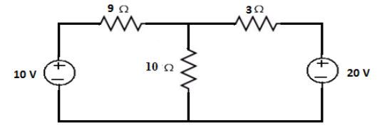 | L4 | CO4 | [8M]
11. | a) | Estimate the value of R_{L} so that maximum power is delivered to the load resistance shown in figure.  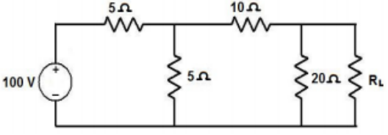 | L2 | CO5 | [8M]
 |  | OR
 | b) | Calculate the y parameters for the following two-port network shown in figure  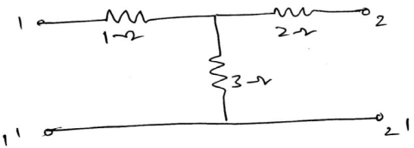 | L3 | CO5 | [8M]
12. | a) | Create the expression for the current i(t) in the circuit shown in figure . The initial voltage across the capacitor is 10 V and the initial current in the inductor is 5A.  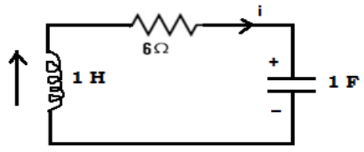 | L6 | CO6 | [8M]
 |  | OR
 | b) | Generalize the expression for the transient current in series RC circuit with AC excitation. | L2 | CO6 | [8M]

-- 00 -- 00 –

